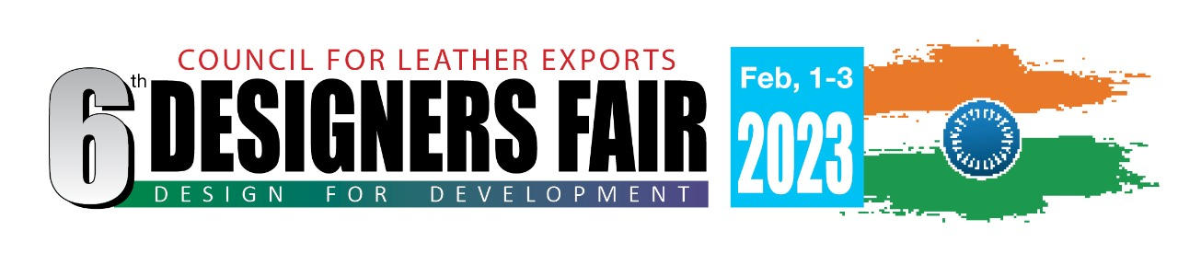
Sub : 6th Designers Fair, Feb. 1-3, 2023
Dear Designer
Greetings from Council for Leather Exports (CLE), sponsored by Ministry of Commerce and Industry, Government of India !
As you know, CLE has organised five successful editions of the Designers Fair.
The 5th edition of Designers Fair held from Feb. 1-3, 2020 in Chennai attracted 51 designers from 47 companies/ institutions and 10 countries who displayed their wide range of designs of leather goods, footwear, printed leather etc., in this event. The designers have reported that the Designers Fair 2020 generated more than 800 business meetings.
We are pleased to inform you that the 6th edition of the Designers Fair will be held at Chennai, India during Feb. 1-3, 2023. The venue will be decided shortly. As in the past editions, overseas and Indian designers will be displaying their projects/designs in a fully constructed stand, for holding discussions with Indian companies for purchase of those designs.
We are providing an attractive package to the designers for their participation in the fair. The details are enclosed. I invite you to participate in 6th edition of Designers Fair. There are no restrictions on the type of samples to be displayed in the fair. Designers can carry wide range of latest innovative samples for any season.
Kindly send the duly filled application form (copy enclosed) along with copy of your passport and product photos at the earliest. Please note that it is necessary to firm-up the list of Designers immediately to go ahead with the event and hence your kind co-operation is requested in sending the application form. Only 35 overseas designers can be accommodated in the fair and hence your early application is solicited. Upon confirmation of your application from our end, you may book air tickets.
I look forward to receiving your immediate confirmation.
Thanks and regards
Naresh Bhasin
Convenor - Designers Fair
COUNCIL FOR LEATHER EXPORTS, INDIA

Designers Fair, Feb. 1 – 3, 2023, Chennai
PACKAGE FOR DESIGNERS

- Sponsorship of return Air Ticket subject to ceiling of Euro 650 for Europe and USD 800 for USA per Designer and USD 450 for Asia.

- Free Hotel Accommodation for 4 nights from Jan. 31- Feb. 3, 2023 + facility for early check-in (i.e. check-in prior to 12 noon of January 31, 2023 in case of early arrival of flights). Arrival can be planned in the morning/afternoon of Jan. 31, 2023. Only bed and breakfast are covered in hotel accommodation. Additional charges for use of SPA, room service, restaurant, bar, mini-bar in the room, gymnasium etc., will have to be borne by the designers.

- Complimentary Airport-pick-up and Drop

- Complimentary breakfast (included in hotel package) from Feb. 1-3, 2023 and lunch from Feb.1 - 3, 2023. Complimentary Dinner on February 1 & 2, 2023

- Complimentary Fully Constructed Stand of 9 sq.mtr for displaying Design Projects/ Products which will include Name Board, Spot Lights, Shelves/Rails, Carpeting, One Table and 3 Chairs. The stand will be a closed stand.

- Visa recommendation letter from Council for Leather Exports

- No restrictions on the type of samples to be carried. Designers can carry samples for the fall /winter 23 or spring /summer 24 season or any innovative and appropriate designs.

- Excess baggage if any, incurred by the Designers can also be refunded after the fair, subject to submission of receipts showing excess baggage payment to the airline, subject to a maximum ceiling of USD 200 or Euro 200 per person (both ways).

**********
6th Designers Fair, Feb. 1-3, 2023
Organised by
COUNCIL FOR LEATHER EXPORTS
(Sponsored by Ministry of Commerce & Industry, Govt. of India)

APPLICATION FORM FOR DESIGNERS

Name of the Company

Name of the Designer

Address

Phone

Fax

e-mail

Website

Name of the Designer Attending the Fair

Design Prototypes/ Products to be displayed and sold in the fair
(Season, Products covered etc.,)

Major achievements of the Designer in the past (working with brands, awards received, innovations done etc.,) .

Brief History of your company/
Designer Profile

Passport details of Designer attending the Show
Name as per Passport
Date of birth
Passport Number
Date of Issue
Date of Expiry
Place of Issue
Bank Account Details of Designer

Account Holder Name

Account Number

Bank Name

Bank Address

IBAN Number

SWIFT Code

Along with the application, please send the following.

Please send copy of your passport page containing photo and passport number

Please send 4-5 Product photographs designed by you (Soft copy)

SIGNATURE & NAME :

DESIGNATION :

DATE :

Note : Please send the application form (scanned copy/soft copy) by e-mail to cle@cleindia.comor gokul@cleindia.com along with Design Photographs (4-5 nos) and passport copy.

